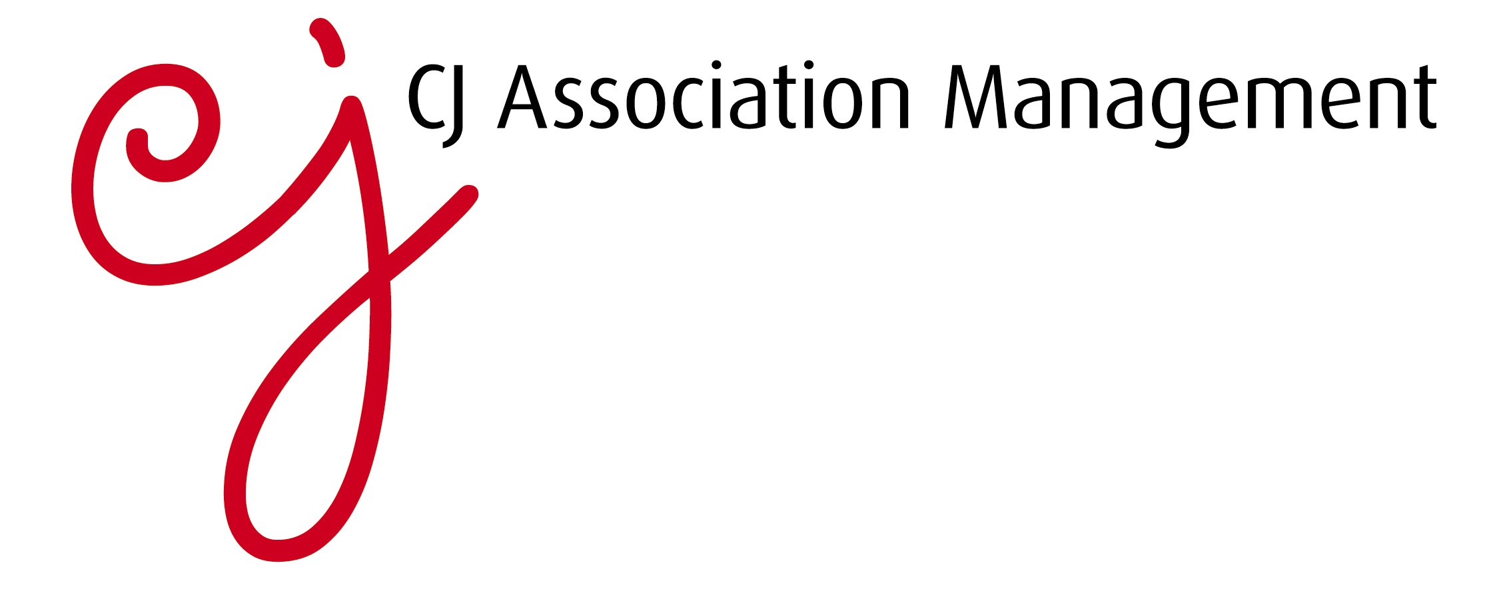

Running an association or membership organisation

Running an association or membership organisation is highly challenging. Outsourcing keeps costs down while helping your organisation to grow. Experienced association management professionals can help you to increase your membership, retain existing members for longer and deliver added value to members, avoiding the need to employ additional in-house staff. Services outsourced often include membership management, administration, marketing and events.

Attracting and retaining members
While the membership of some associations ticks over without any significant peaks and troughs, many devote a lot of time and resource to recruiting and retaining members, suffering financial losses year on year through member churn. This is particularly true when an industry is largely made up of numerous small companies and there’s no obligation for them to join.

In general terms, people may be less inclined to join industry associations due to the many other demands on their time. With a tough economic climate, it can be hard to motivate busy professionals to leave the office for industry events. Add the fierce competition among trade associations themselves to attract members, and the task of growing membership becomes even more challenging.

Today’s trade associations simply can’t afford to be complacent about their membership. Outsourcing the business of winning and retaining members offers distinct advantages. A specialist association management team will know exactly how to sell the positive benefits of joining to members and how to package the services available in a compelling way, significantly increasing the chances of industry members joining.

In the same way, a specialist team will be able to deliver a structured and engaging programme of interesting events and relevant content, helping members to see the value of their membership at every turn.

Improving efficiency
It’s vital that trade associations are run efficiently in order to save both time and cost. Adopting smarter processes and embracing new technologies are all fundamental to ensuring the smooth running of an organisation. In particular, moving away from paper-based systems to email communications and social media means communicating with members is more rapid, and importantly, communications are more likely to be read. Most professionals now expect to quickly find information online, so designing and maintaining an engaging, user-friendly website is key, as is distributing regular e-newsletters. Members will also expect events, briefings and conferences to run like clockwork.

Outsourcing communications, publications and events to association management professionals helps to ensure that members remain happy with the quality of information they receive and the activities they attend. Getting this right can pay dividends in terms of retaining members and demonstrating value-for-money services.

Meanwhile, outsourcing membership management and accounting activities to association management companies can enhance the administrative efficiency of associations immeasurably. Specialists will stay up-to-date with legal and financial regulations, and will often have in-house accounting experts to deal with complex reporting and tax issues. Even outsourcing the deluge of calls and emails received daily by most associations can pay dividends in freeing up in-house teams’ time to tackle more pressing business challenges.

Experienced association management professionals will act as an extension to your team and help enhance your brand image by interacting positively with members.

Saving employment costs
Trade associations and membership organisations often experience variable volumes of work depending on the time of year, major industry announcements or particular events in their calendar. Juggling staffing levels to account for surges in activity can be challenging, so developing a good relationship with association management professionals can help to ensure that associations have the right help in place ahead of any peaks in activity. Appointing an outsourced secretariat can help to ensure that associations navigate busy periods efficiently, while running a lean, cost-effective in-house team.

